Preparation:

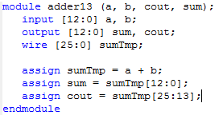

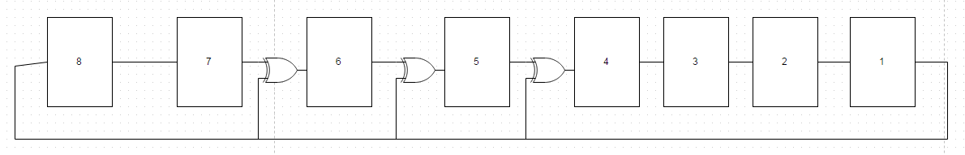

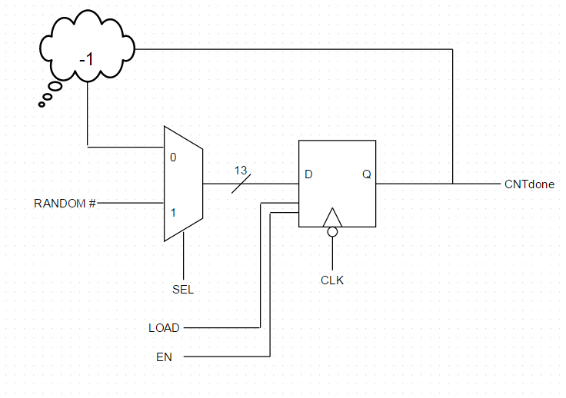

8 Bit LFSR:

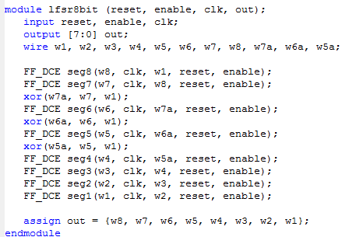

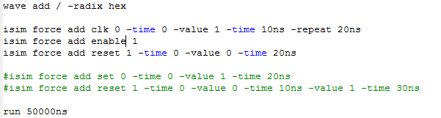

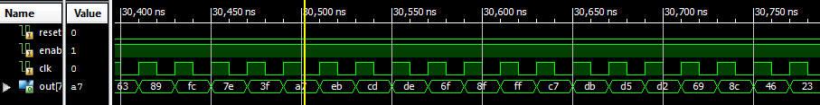

13 Bit Down Counter:

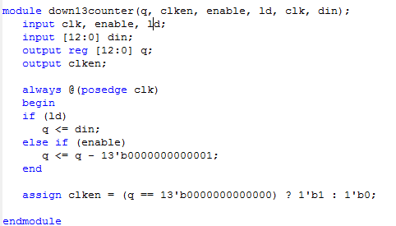

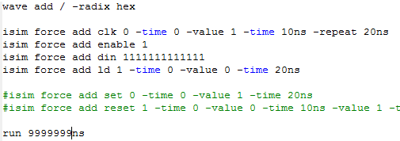

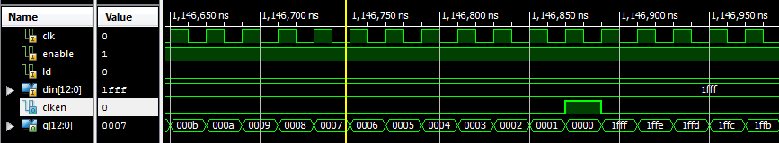

Delay Timer:

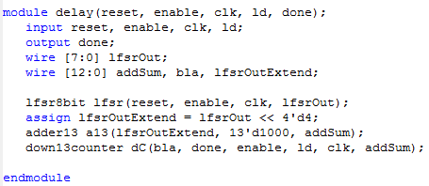

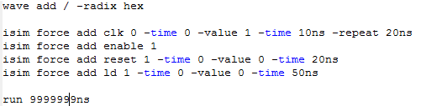

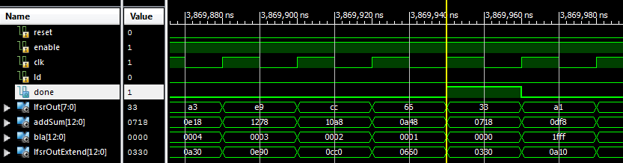

Scoring Unit:

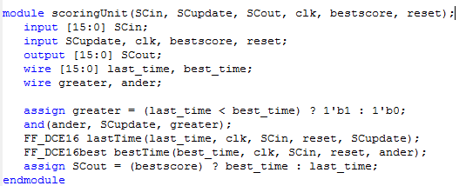

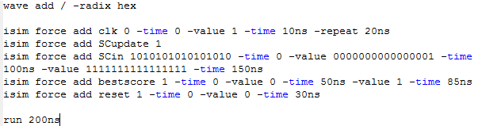

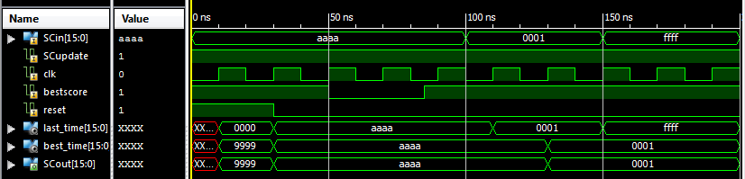

Anomalies:

This lab was not really too bad at all. The instructions were infinitely more helpful than any previous lab. The only caveat with that was that the TA’s did not have experience with this lab so they weren’t able to help as much, which was okay because they didn’t really need to.